Загальноосвітня школа І-ІІІ ступенів с.Поділля

The pupil of the 6th form

Teacher: Oksana Ryzhevska

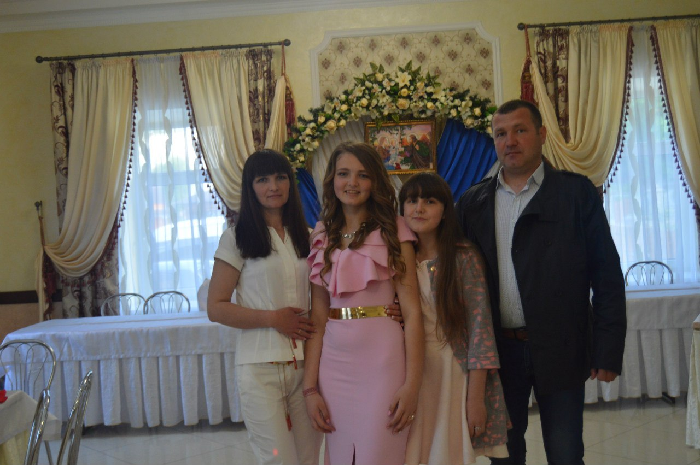



All About Me

My name: Valeriya
My surname: Pyptchuk
Date of birth: 27.03.2004
Age: 12 years
Form: 6
My English Teacher’s name:
Oksana Ryzhevska


My Family Tree
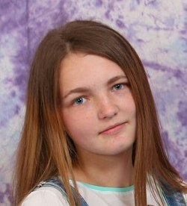
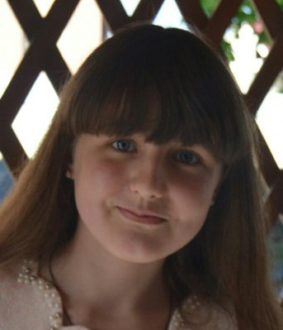
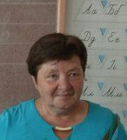
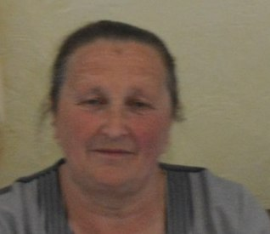
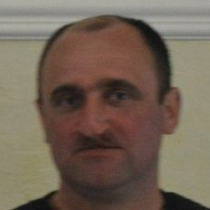
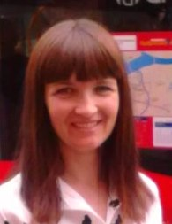
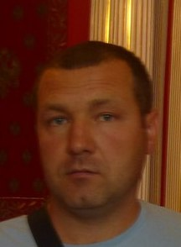
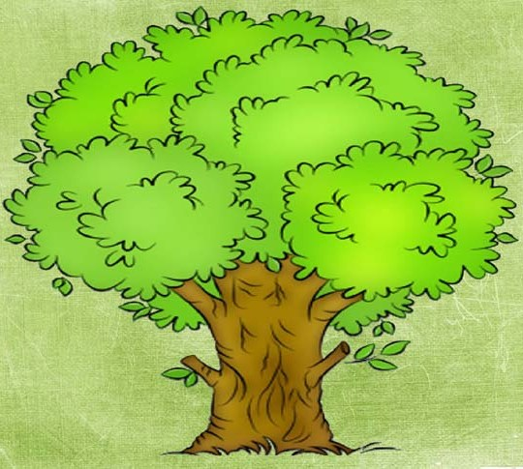
My grannies Iryna and Mariya
My sister Tania
Me
My uncle Vasyl
My mother Galyna
My father Mykola

My family is happy. I like my family very much.
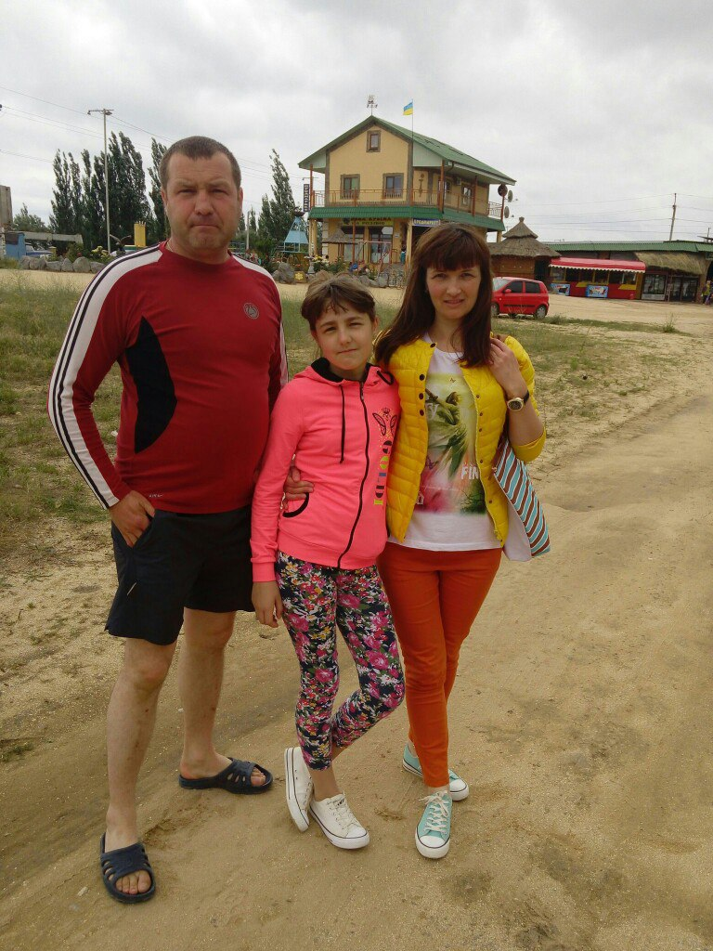
We like to spend time together. We like to travel, to have a rest, to visit new places together.
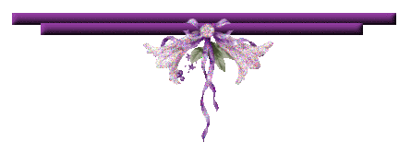

My sister Tania is my best friend.
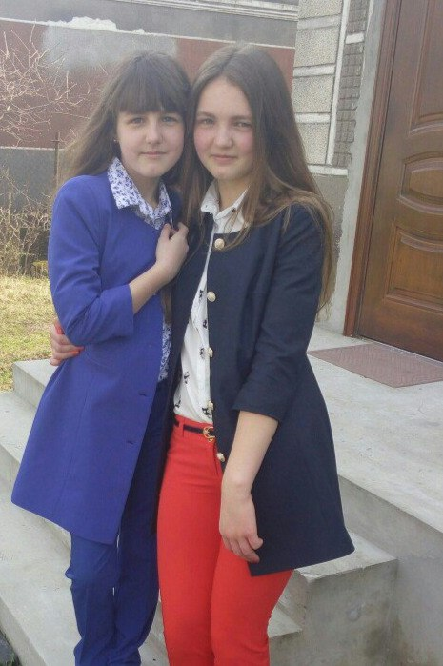
She always helps me and she knows all my secrets.

In the evenings we often gather in the kitchen by the cup of tea, chatting, laughing and discussing the events of the day. Those evening are the best of all.
We have united family and always help each other.





